10.2 Sprint 2 – Data Immutability

Sprint Description | Sprint Start Date | Sprint End Date
Database Immutability | 10/02 | 02/03

Items Covered in Sprint:
Item ID | Issue Description | Status
FYPID-7 | Create Immutable Record | DONE
FYPID-8 | Retrieve Immutable Record | DONE
FYPID-9 | Retrieve Subset of Data | DONE
FYPID-10 | Semi Immutable Data Record | DONE
FYPID-11 | Data History | DONE
FYPID-13 | Database Schema / Constraints | DONE
FYPID-36 | Refactoring For Tech Debt - Sprint 2 | DONE
FYPID-37 | Basic UI Front-end | DONE

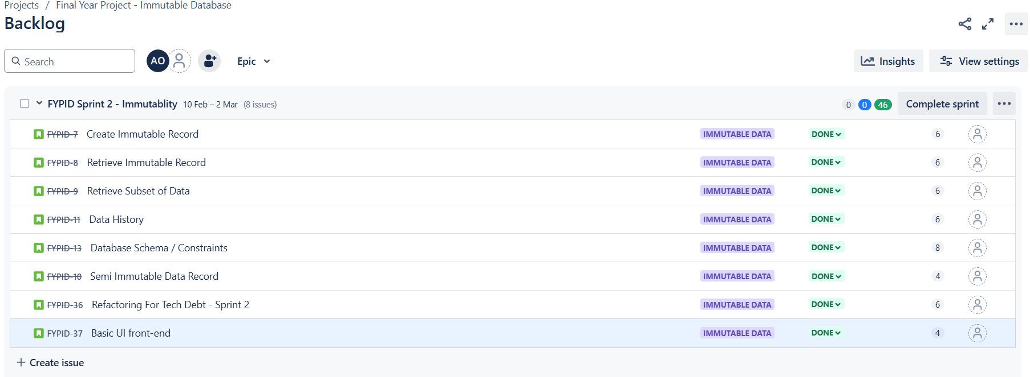
Figure 58 - Sprint 2 End Snapshot

10.2.1 Create Immutable Record. FYPID-7
To guarantee data immutability, a core principle of this database engine, all insert operations are implemented as append-only.
This means that new data is always added to the end of the data store, and existing data is never modified in place.
The insert row function has been enhanced to handle a variety of scenarios, including cases where column names are omitted, provided in a different order than the schema defines, or contain incomplete data.
Full validation of all incoming rows is performed to ensure data integrity and adherence to schema constraints.
This rigorous approach to data insertion is fundamental to preserving the immutable nature of the database.

10.2.2 Retrieve Immutable Record. FYPID-8
The ability to efficiently and accurately retrieve data is a fundamental requirement of any database engine.
This functionality is achieved through SELECT statements, which are processed by the SQL parser and then handled by the table.rs module.
This module is responsible for accessing the underlying data store and retrieving the requested records based on the parsed query.
This ensures that data retrieval operations are performed correctly and efficiently, providing users with the expected results.

10.2.3 Retrieve Subset of Data. FYPID-9
Building upon the basic record retrieval functionality, this feature enables users to query and retrieve specific subsets of data from the database.
This is accomplished through the use of WHERE clauses in SELECT statements.
These clauses allow users to specify conditional expressions that filter the data based on defined criteria. The system supports a standard set of comparison operators for numeric and string data types, including <, >, =, >=, <=, and !=.
For string comparisons, the = operator provides exact matching, while a simple regex implementation supports partial string matches using the LIKE operator (e.g., LIKE 'bo%' to match strings beginning with "bo").
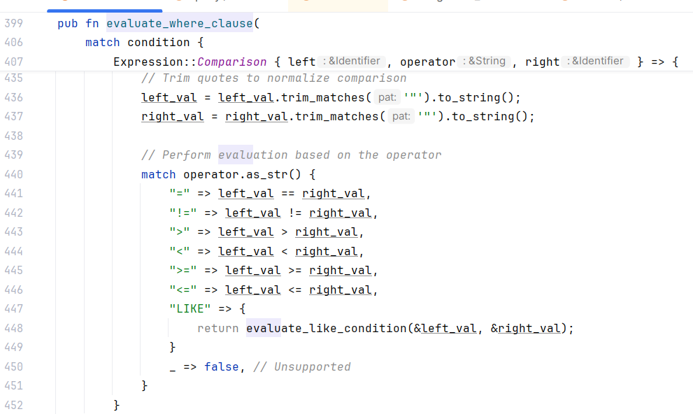
Figure 59 - Expression Evaluation
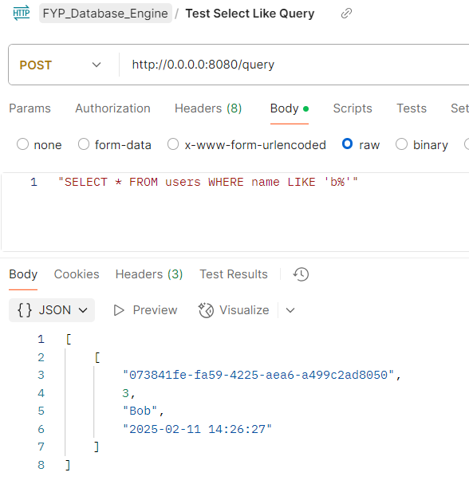
Figure 60 - Select with Like Clause

10.2.4 Semi Immutable Data Record. FYPID-10
Implementing update functionality while preserving immutability required significant architectural changes.
The solution involves storing data in separate, append-only files. Initial data insertions are stored in a file named <table_name>_initial, while subsequent updates are stored in a separate file named <table_name>_updates.
This separation maintains the immutability of the original data while providing a clear audit trail of changes.
Current data is maintained in an ephemeral in-memory cache for performance. This cache can be regenerated as needed using the recalculate_table function.
To improve efficiency, a recalculate_row function is also provided, allowing for the selective recalculation of individual rows, eliminating the need to rebuild the entire table cache after every update.
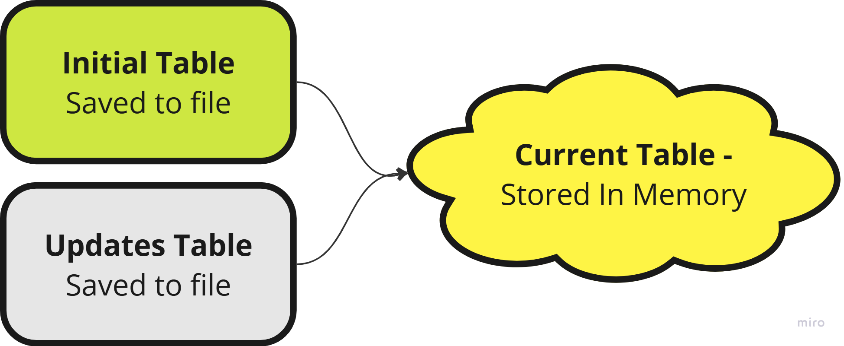
Figure 61 - Simplified tables diagram

10.2.5 Data History. FYPID-11
Along with the changes above, the next major change is the addition of timestamps to all records. the recalculate functions mentioned above makes use of this to ensure that updates added non sequentially can be re-organised to ensure current data is the most recent version of that record.
This allows a new functionality to be added to the database, which is versioning/ data history, a new specialised select query has been added which returns the state of a table at a specified timeframe.
The AT keyword was chosen to achieve this. However, it may be changed at a later date to AT_TIMESTAMP to avoid potential misuse.
Current table select:
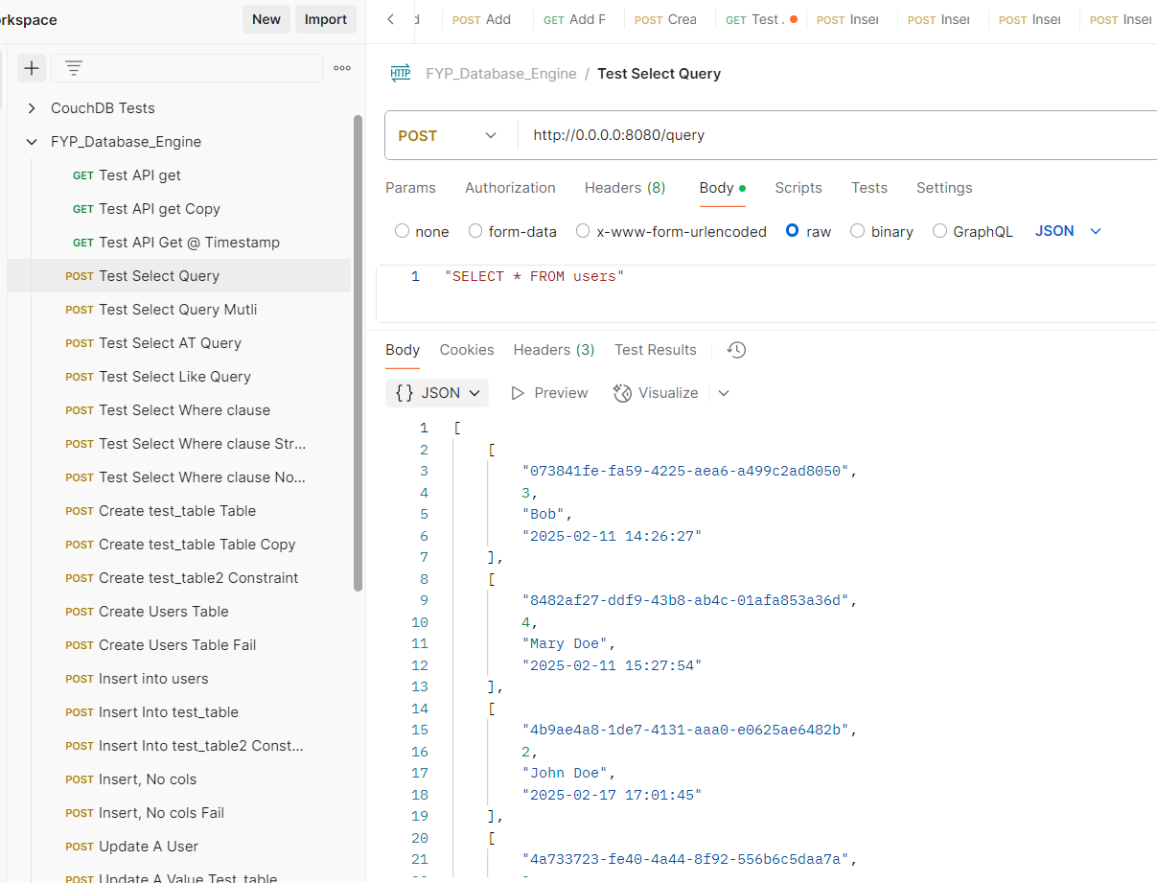
Figure 62 - Current Table Select
With AT select statement:
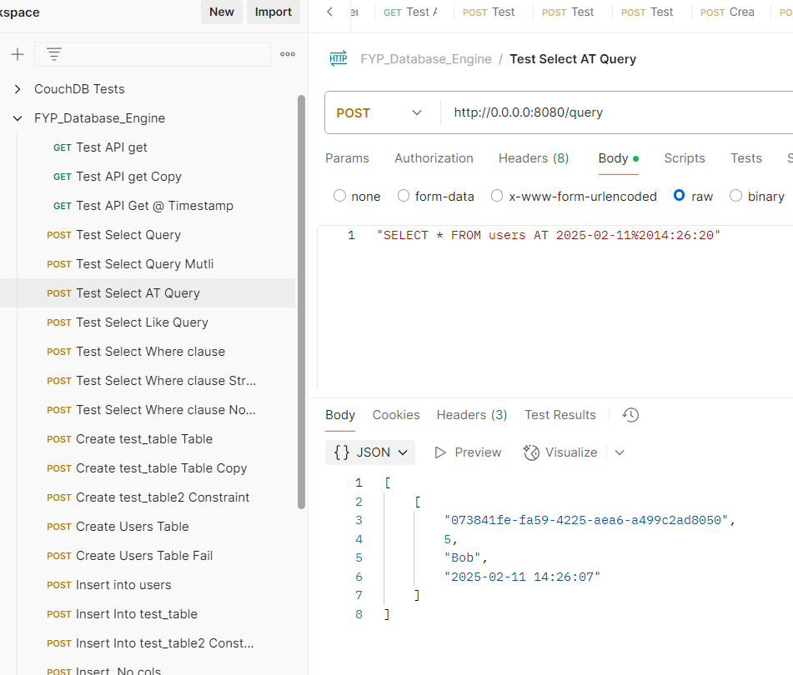
Figure 63 - Select with AT Timestamp

10.2.6 Database Schema / Constraints. FYPID-13
Data integrity is enforced through schema definitions and constraints.
The CREATE TABLE statement now allows for the definition of constraints such as NOT NULL, UNIQUE, and custom checks (e.g., ensuring numeric values are greater than zero).
These constraints are validated during data insertion and update operations by the validate_and_process_row function, preventing invalid data from being stored in the database.
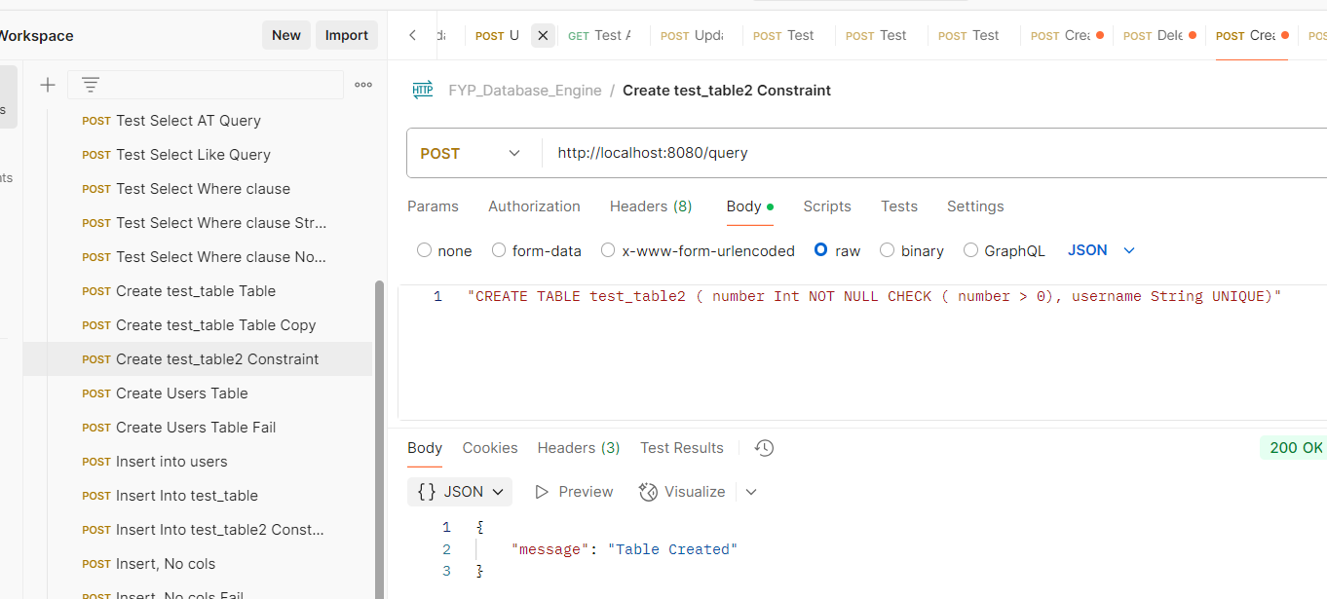
Figure 64 - Create Table with Constraints
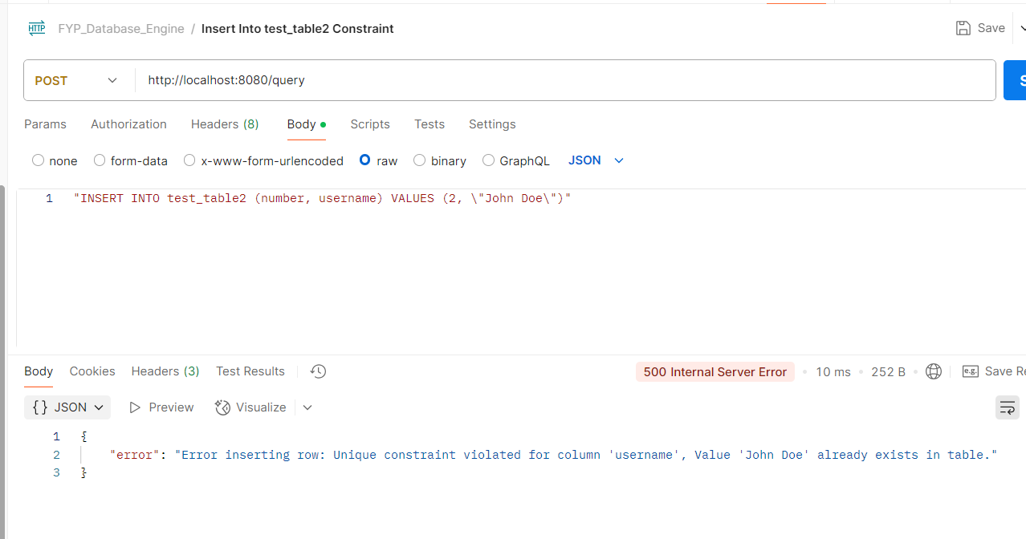
Figure 65 - Constraint Violation example

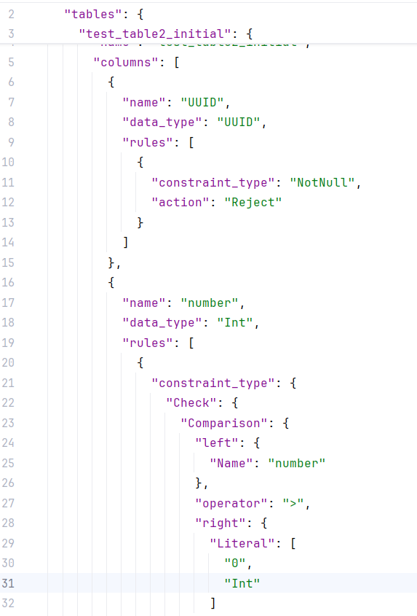
Figure 66 - Data Constraints saved in Schema.json file

10.2.7 Refactoring for Tech Debt - Sprint 2. FYPID-36
The extensive changes implemented in this sprint necessitated a significant refactoring effort to address accumulating technical debt and maintain a clean and maintainable codebase.
This unforeseen effort consumed a considerable portion of the sprint's development time.
Moving forward, a dedicated allocation of approximately 20% of development time in future sprints will be dedicated to addressing technical debt accrued from previous sprints.
The most substantial refactoring occurred within the parser.rs and executor.rs files, where core functionalities were extracted into more modular and manageable handler methods, improving code organization and readability.

10.2.7 Basic UI front-end for database. FYPID-37
A basic user interface (UI) has been developed to facilitate interaction with the immutable database.
The UI features a text area for executing SQL queries, providing a familiar mechanism for data access and manipulation.
A dedicated "Tables" section displays the available tables within the database.
Clicking a table name dynamically loads and displays the table's data, presented with clear column headers for easy readability.
This initial UI provides core interaction capabilities, focusing on query execution and data browsing, and serves as a foundation for potential future enhancements.
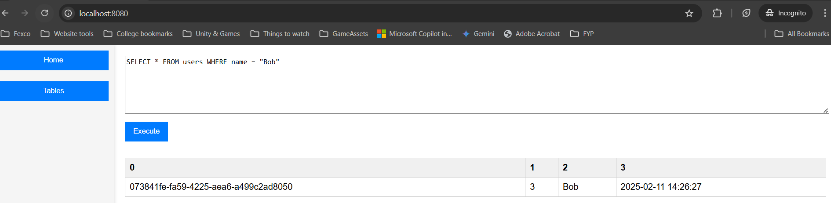
Figure 67 - Example execution from front end
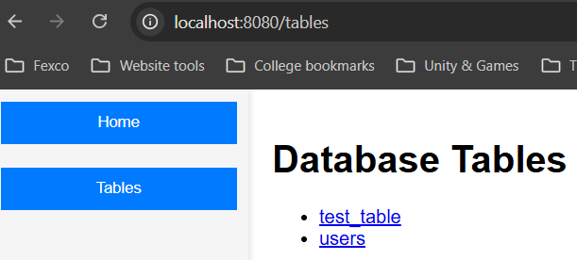
Figure 68 - Front end Tables page
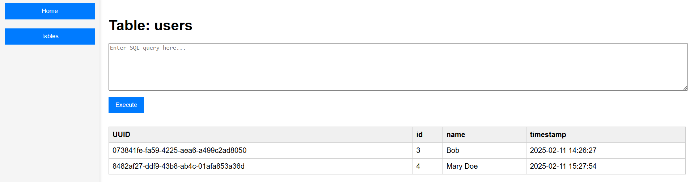
Figure 69 - Front end Users Table

